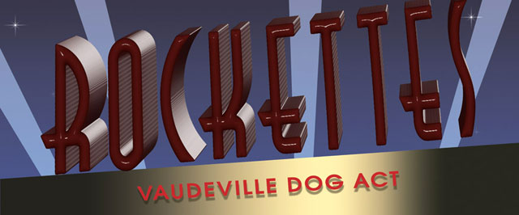

By Pat Gellerman
﻿This is a story of a Vaudeville dog act featuring Afghans and two Radio City Music Hall Rockettes. They all performed in the Sixties. Today, these former Rockettes are still in show business - dog show business, that is.
In 1961, Diane Chiucchi joined her older sister as a Radio City Music Hall Rockette. Around the same time, Romayne Strilka-Switch joined her sister as a member of the Radio City Rockettes. These were the only two sets of sisters in the famous dance corps at that time. But this wasn’t the only distinctive thing about these two women.
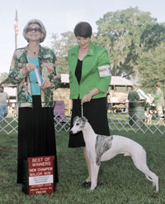 | 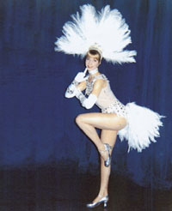
Diane Chiucchi in 2006 | Diane Chiucchi as a  Radio City Music Hall Rockette in 1961
Both visited the dog room at the Music Hall as much as their free time from dancing would allow. There was a dog act on the stage and it featured Afghans. Both Ro-mayne and Diane fell in love with these dogs, brushing and petting them. Today, Diane is show chairman of the Pasco Ken-nel Club in Brooksville, Florida and Romayne is an AKC judge of the Hound Group and Bearded Collies.
When Diane joined the Music Hall in New York, she joined her sister who was already a Rockette. She danced with the Rockettes in the summer while on vacation from high school and came to New York City to dance after her graduation. Diane’s parents were professional dancers and became dance instructors when they retired.
Diane married her first husband in Ithaca, New York and then moved with him to Boca Raton, Florida. Her husband’s aunt bred Afghans and had acquired her Afghans from Gold Coast Afghans, owned by breeder Jim Pierce. That is where Diane bought her first Afghans. She never forgot those Afghans in the Radio City show.
After divorcing her first husband, Diane moved back to Ithaca and was followed there by Ralph Chiucchi, who became her second husband. She stopped showing Afghans when her daughter was born in 1981, and when her daughter turned 14, she decided to start breeding Whippets. She visited Sporting Fields Whippet Kennel in Pennsylvania and acquired her first Whippets there. She now has 12 Whippets and is active in the Whippet ring.
“When my husband and I moved to Brooksville, Florida because of his work, we joined the Pasco Kennel Club. He is now president and I am show chairman,” Diane told us. Diane still belongs to the Finger Lakes Kennel Club, which she joined years ago when she lived in Ithaca.
Diane now runs a dance studio in Brooksville. Both are still exhibiting dogs and teaching dancing - they can’t get show business out of their systems.
This author, who lived in New Jersey, never missed the Christmas Show in Radio City and went to almost every show each month in New York. I am sure I watched these two women dance for many years. I have introduced my children and grandchildren to the Rockettes as well. It is a tradition that these two ladies are still carrying on in their teaching while also staying in show business – the dog show business that is.

